Simulation Workbook: International Relations



Fall 2020 Edition

Josh Franco, Ph.D.

Cuyamaca College

Page Intentionally Left Blank

Simulation Workbook: International Relations

  - Fall 2020 Edition

Josh Franco, Ph.D., Cuyamaca College

Simulation Workbook: International Relations is an Open Education Resource licensed under Creative Commons
Licensed under Creative Commons - Attribution - Non-Commercial
Simulation Workbook: International Relations, Fall 2020 Edition, is licensed under Creative
Commons - Attribution - Non-Commercial (CC BY-NC).

To learn more, please visit:
https://creativecommons.org/licenses/by-nc/2.0/.

This open education resource is dedicated to Ethan, my son, and future generations
Brief Table of Contents
Preface xi
Chapter 1: Overview 1
Chapter 2: Domestic Politics 2
Chapter 3: International Politics 4
Chapter 4: Complex Interaction 6
Chapter 5: Strategic Interaction 8
Chapter 6: Foreign Crisis 9
Chapter 7: Share 11
Chapter 8: My Reflection 13

Table of Contents
Preface xi
Chapter 1: Overview 1
About 1
Chapter 2: Domestic Politics 2
About 2
Estimated Time 2
What is Domestic Politics? 2
Why are Domestic Politics important in an International Relations course? 2
What Domestic Political Actors shape International Relations? 2
1. Group 1: Executive Branch 2
2. Group 2: Environmental Organizations 2
3. Group 3: Private Corporations 2
4. Group 4: The Media 2
5. Group 5: The Public 2
6. Group 6: Legislative Branch 2
7. Group 7: Human Rights Organizations 2
8. Group 8: Labor Unions 2
Instructions 2
Step 1: Select Domestic Political Actors 2
Step 2: Explain your Selected Domestic Political Actors 2
Rubric 2
Chapter 3: International Politics 4
About 4
Estimated Time 4
What is International Politics? 4
Why are International Political Actors important? 4
What International Political Actors shape International Relations? 4
1. Group 1: Organization of the Petroleum Exporting Countries 4
2. Group 2: China 4
3. Group 3: European Union 4
4. Group 4: International Monetary Fund 4
5. Group 5: Russia 4
6. Group 6: United Nations 4
7. Group 7: North Atlantic Treaty Organization 4
8. Group 8: World Bank 4
Instructions 4
Step 1: Select International Political Actors 4
Step 2: Explain your Selected International Political Actors 4
Rubric 4
Chapter 4: Complex Interaction 6
About 6
Estimated Time 6
What is Complex Interaction? 6
Why is Complex Interaction important in International Relations? 6
What are network models of complex interaction? 6
Instructions 6
Step 1: Select a network model 6
Step 2: Explain why you selected a particular network model 6
Rubric 6
Chapter 5: Strategic Interaction 8
About 8
Estimated Time 8
What is Strategic Interaction? 8
Why is Strategic Interaction important in International Relations? 8
What are game theoretic models of strategic interaction? 8
What are methods to solving a game theoretic model? 8
Instructions 8
Step 1: Select a game theoretic model 8
Step 2: Solve the game theoretic model using the solution method above 8
Step 3: Explain why you selected a particular game theoretic model 8
Rubric 8
Chapter 6: Foreign Crisis 9
About 9
Estimated Time 9
What is a Foreign Crisis? 9
Why are Foreign Crises important in International Relations? 9
How can a Foreign Crisis spill into domestic politics? 9
Types of Foreign Crises 9
1. Biological weapons attack 9
2. Chemical weapons attack 9
3. Cyberattack 9
4. Major conflict 9
5. Minor conflict 9
6. Nuclear weapons attack 9
7. Outer Space anomaly 9
8. Pandemic 9
9. Trade war 9
10. Virus outbreak 9
Instructions 9
Step 1: Select a Foreign Crisis 9
Step 2: Describe how the foreign crisis affects an international political actor 9
Step 3: Describe how the foreign crisis affects a domestic political actor 9
Step 4: Describe how the foreign crisis requires a domestic political actor to strategically interact with an international political actor 9
Step 5: Describe how the foreign crisis restructures a complex network 9
Rubric 9
Chapter 7: Share 11
About 11
Estimated Time 11
Instructions 11
Step 1: Post 11
Step 2: Reply to a Peer’s Post 11
Rubric 11
Chapter 8: My Reflection 13
About 13
Estimated Time 13
Instructions 13
Rubric 13

Preface

The political science sub-field of International Relations is the study of who gets what, when, where, how, and why primarily at the international level.

International Relations has a long and rich history in world history and politics. A major advancement in the sub-field came with the introduction of formal game theory in the 1950s, and shift from traditional “isms” of realism, liberalism, and constructivism to the interest, interactions, and institutions framework, and the growing connection between domestic and international politics due to social media.

The Simulation Workbook: International Relations is a derivate of my general Simulation Workbook, which is a staple in my U.S. Government and Politics courses.

While the Simulation Workbook focuses on levels, status quo, political actors, network, ad bridging, the International Relations version of the work centers on key concepts of domestic politics, international politics, complex interaction, strategic interaction, and foreign crisis.

The standard principle for both workbooks is to not think of simulations in the tradition sense of role-playing exercises. Rather, I want you, my students, to think of simulations as the development of abstract reasoning and the formulation of a working mental model that you can carry with you long after the conclusion of this course.

Chapter 1: Overview

About
Simulations "are the imitative representation of the functioning of one system or process by means of the functioning of another or something that is made to look, feel, or behave like something else especially so that it can be studied or used to train people" (Merriam-Webster).
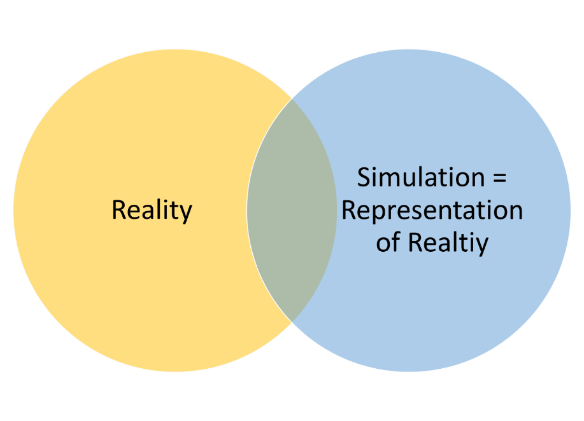
In political science, role-playing simulations are commonly used to teach students about operating a congressional committee hearing, hosting a Model Arab League, re-enacting a historical political event (like the Cuban Missile Crisis), or presenting oral arguments before the U.S. Supreme Court.

However, this simulation does not follow tradition. Rather, it is out goal to think of simulations as the development of abstract reasoning and the formulation of a working mental model that you can carry with you long after the conclusion of this course.

For our course, I want us to focus on the abstractions underlying International Relations simulations: domestic politics, international politics, complex interactions, strategic interactions, and foreign crises.

Chapter 2: Domestic Politics

About
SIM – Domestic Politics is an Assignment where you explore the concept of the domestic politics and domestic political actors.

Estimated Time
An estimated 90 minutes is needed to complete this activity.

What is Domestic Politics?
Domestic politics is the struggle of who gets what, when, where, how, and why within a country.

The key here is that domestic politics focuses exclusively on what happens inside the borders of a country.

Why are Domestic Politics important in an International Relations course?
Domestic politics are important in an international relations course for four reasons.

- First, domestic politics can set the range of actions domestic political actors can take on the international level.

- Second, domestic politics, while seemingly impervious to international events and actors, is susceptible to foreign events and actors given the increasing connections between people, communities, businesses, and governments throughout the world.

- Third, domestic politics can spillover beyond the traditional gates of government and military channels to shape international dialogues, instigate international events, and drive international actors to react. In other words, domestic politics can affect international matters in observable and less observable ways.

- Finally, domestic politics is where we start. Barring those of us who were born in one place, and then grew up in multiple places around the world, domestic politics is what anchors our understanding of politics in general.

What Domestic Political Actors shape International Relations?
While there can be a range of domestic political actors that shape international relations, below is a list of eight major groupings of actors:

Group 1: Executive Branch
- Definition: “the branch of government charged with the execution and enforcement of laws and policies and the administration of public affairs; the executive.” (Dictionary)

Group 2: Environmental Organizations
- Definition: “An environmental organization is an organization coming out of the conservation or environmental movements that seeks to protect, analyze or monitor the environment against misuse or degradation from human forces.” (Wikipedia)

Group 3: Private Corporations
- Definition: “a corporation that is not a public corporation : a corporation organized for the profit of its members or in which the entire interest is not held by the state” (Merriam-Webster)

Group 4: The Mass Media
- Definition: “a medium of communication (such as newspapers, radio, or television) that is designed to reach the mass of the people —usually used in plural” (Merriam-Webster)

Group 5: The Public
- Definition: “: of, relating to, or affecting all the people or the whole area of a nation or state” (Merriam-Webster)

Group 6: Legislative Branch
- Definition: “the branch of government having the power to make laws; the legislature.” (Dictionary)

Group 7: Human Rights Organizations
- Definition: “A human rights group, or human rights organization, is a non-governmental organization which advocates for human rights through identification of their violation, collecting incident data, its analysis and publication, promotion of public awareness while conducting institutional advocacy, and lobbying to halt these violations.” (Wikipedia)

Group 8: Labor Unions
- Definition: “A trade union (or a labor union in the U.S., or a union in Australia) is an association of workers forming a legal unit or legal personhood, usually called a "bargaining unit", which acts as bargaining agent and legal representative for a unit of employees in all matters of law or right arising from or in the administration of a collective agreement.” (Wikipedia)

Instructions

Step 1: Select Domestic Political Actors
- Select two Domestic Political Actors that most intrigue you.

Step 2: Explain your Selected Domestic Political Actors
In 5-sentences or more, explain the two Domestic Political Actors you selected. You can use the following questions to help explain your choice:
- Which two Domestic Political Actors most interest you and why?
- What is a real-world example of one or both domestic political actors?
- What is at least one trade-off in focusing on two Domestic Political Actors versus all the Domestic Political Actors?
- What is at least one benefit of using two Domestic Political Actors versus using just one Domestic Political Actors?

Rubric
Criteria | Ratings | Points
1st Political Actor selected | Yes  No | 25  0
2nd Political Actor selected | Yes  No | 25  0
Explanation Quantity: # Sentences | 5 sentences  4 sentences  3 sentences  2 sentences  1 sentence  Missing | 50  40  30  20  10  0
Quality: Subjective evaluation by Professor | 01 – Superb  02 – Excellent  03 – Great  04 – Good  05 – Insufficient | 0  0  0  0  0

Chapter 3: International Politics

About
SIM – International Politics is an Assignment where you explore the concept of the International politics and International political actors.

Estimated Time
An estimated 90 minutes is needed to complete this activity.

What is International Politics?
International politics is the struggle of who gets what, when, where, how, and why throughout the globe.

International politics is sometimes viewed not a completely global matter, but as struggles between two global superpowers (ex: USA and USSR during the Cold War), struggles between superpowers and great powers, and regional struggles between two or more countries in close geographic proximity to one another.

The key here is that international politics focuses exclusively on what happens outside the borders of any single country.

Why are International Politics important?
International politics are important for three reasons:
- First, international politics can set the range of actions international political actors can take on the global stage.
- Second, international politics shapes the motives and behaviors of governments, businesses, influence trade, immigration, humanitarian assistance, environmental efforts, and shape international norms, customs, laws, and cultures. International politics is complex, as we will explore later, so we acknowledge it’s macro effects on governments, businesses, and people, as well as its micro effects on individuals and communities throughout the world.
- Third, international politics can spillover beyond the traditional gates of government and military channels to shape domestic dialogues, instigate domestic events, and drive domestic actors to react. In other words, international politics can affect domestic matters in observable and less observable ways.

What International Political Actors shape International Relations?

Group 1: Organization of the Petroleum Exporting Countries
- “OPEC is a permanent intergovernmental organization of 13 oil-exporting developing nations that coordinates and unifies the petroleum policies of its Member Countries. OPEC’s formation by five oil-producing developing countries in Baghdad in September 1960 occurred at a time of transition in the international economic and political landscape, with extensive decolonisation and the birth of many new independent states in the developing world. ” (OPEC)

Group 2: China

- “China's historical civilization dates from at least 1200 B.C.; from the 3rd century B.C. and for the next two millennia, China alternated between periods of unity and disunity under a succession of imperial dynasties. In the 19th and early 20th centuries, the country was beset by civil unrest, major famines, military defeats, and foreign occupation. After World War II, the Chinese Communist Party under MAO Zedong established an autocratic socialist system that, while ensuring China's sovereignty, imposed strict controls over everyday life and cost the lives of tens of millions of people. After 1978, MAO's successor DENG Xiaoping and other leaders focused on market-oriented economic development and by 2000 output had quadrupled. For much of the population, living standards have improved dramatically but political controls remain tight. Since the early 1990s, China has increased its global outreach and participation in international organizations.” (CIA World Factbook)

Group 3: European Union
- “The European Union (EU) is a political and economic union of 27 member states that are located primarily in Europe.[11] Its members have a combined area of 4,233,255.3 km2 (1,634,469.0 sq mi) and an estimated total population of about 447 million. The EU has developed an internal single market through a standardised system of laws that apply in all member states in those matters, and only those matters, where members have agreed to act as one. EU policies aim to ensure the free movement of people, goods, services and capital within the internal market;[12] enact legislation in justice and home affairs; and maintain common policies on trade,[13] agriculture,[14] fisheries and regional development.[15]” (Wikipedia)

Group 4: International Monetary Fund
- “The International Monetary Fund (IMF) is an organization of 189 countries, working to foster global monetary cooperation, secure financial stability, facilitate international trade, promote high employment and sustainable economic growth, and reduce poverty around the world. Created in 1945, the IMF is governed by and accountable to the 189 countries that make up its near-global membership. The IMF's primary purpose is to ensure the stability of the international monetary system—the system of exchange rates and international payments that enables countries (and their citizens) to transact with each other. The Fund's mandate was updated in 2012 to include all macroeconomic and financial sector issues that bear on global stability.” (IMF)

Group 5: Russia
- “Founded in the 12th century, the Principality of Muscovy was able to emerge from over 200 years of Mongol domination (13th-15th centuries) and to gradually conquer and absorb surrounding principalities. In the early 17th century, a new ROMANOV Dynasty continued this policy of expansion across Siberia to the Pacific. Under PETER I (ruled 1682-1725), hegemony was extended to the Baltic Sea and the country was renamed the Russian Empire. During the 19th century, more territorial acquisitions were made in Europe and Asia. Defeat in the Russo-Japanese War of 1904-05 contributed to the Revolution of 1905, which resulted in the formation of a parliament and other reforms. Devastating defeats and food shortages in World War I led to widespread rioting in the major cities of the Russian Empire and to the overthrow in 1917 of the ROMANOV Dynasty. The communists under Vladimir LENIN seized power soon after and formed the USSR. The brutal rule of Iosif STALIN (1928-53) strengthened communist rule and Russian dominance of the Soviet Union at a cost of tens of millions of lives. After defeating Germany in World War II as part of an alliance with the US (1939-1945), the USSR expanded its territory and influence in Eastern Europe and emerged as a global power. The USSR was the principal adversary of the US during the Cold War (1947-1991). The Soviet economy and society stagnated in the decades following Stalin's rule, until General Secretary Mikhail GORBACHEV (1985-91) introduced glasnost (openness) and perestroika (restructuring) in an attempt to modernize communism, but his initiatives inadvertently released forces that by December 1991 led to the dissolution of the USSR into Russia and 14 other independent states.” (CIA World Factbook)

Group 6: United Nations
- “The United Nations is an international organization founded in 1945. It is currently made up of 193 Member States. The mission and work of the United Nations are guided by the purposes and principles contained in its founding Charter. Due to the powers vested in its Charter and its unique international character, the United Nations can take action on the issues confronting humanity in the 21st century, such as peace and security, climate change, sustainable development, human rights, disarmament, terrorism, humanitarian and health emergencies, gender equality, governance, food production, and more. The UN also provides a forum for its members to express their views in the General Assembly, the Security Council, the Economic and Social Council, and other bodies and committees. By enabling dialogue between its members, and by hosting negotiations, the Organization has become a mechanism for governments to find areas of agreement and solve problems together. The UN's Chief Administrative Officer is the Secretary-General. 2020 marks the 75th anniversary of the United Nations.” (UN)

Group 7: North Atlantic Treaty Organization
- “Security in our daily lives is key to our well-being. NATO’s purpose is to guarantee the freedom and security of its members through political and military means. POLITICAL - NATO promotes democratic values and enables members to consult and cooperate on defence and security-related issues to solve problems, build trust and, in the long run, prevent conflict. MILITARY - NATO is committed to the peaceful resolution of disputes. If diplomatic efforts fail, it has the military power to undertake crisis-management operations. These are carried out under the collective defence clause of NATO's founding treaty - Article 5 of the Washington Treaty or under a United Nations mandate, alone or in cooperation with other countries and international organisations.” (NATO)

Group 8: World Bank
- “With 189 member countries, staff from more than 170 countries, and offices in over 130 locations, the World Bank Group is a unique global partnership: five institutions working for sustainable solutions that reduce poverty and build shared prosperity in developing countries: International Bank for Reconstruction and Development; International Development Association; International Finance Corporation; Multilateral Investment Guarantee Agency; and International Center for Settlement of Investment Disputes” (World Bank)

Instructions

Step 1: Select International Political Actors
- Select two International Political Actors that most intrigue you.

Step 2: Explain your Selected International Political Actors
In 5-sentences or more, explain the two International Political Actors you selected. You can use the following questions to help explain your choice:
- Which two International Political Actors most interest you and why?
- What is at least one trade-off in focusing on two International Political Actors versus all the International Political Actors?
- What is at least one benefit of using two International Political Actors versus using just one International Political Actors?
- What is the membership structure of one or both of the International Political Actors?

Rubric
Criteria | Ratings | Points
1st Political Actor selected | Yes  No | 25  0
2nd Political Actor selected | Yes  No | 25  0
Explanation Quantity: # Sentences | 5 sentences  4 sentences  3 sentences  2 sentences  1 sentence  Missing | 50  40  30  20  10  0
Quality: Subjective evaluation by Professor | 01 – Superb  02 – Excellent  03 – Great  04 – Good  05 – Insufficient | 0  0  0  0  0

Chapter 4: Complex Interaction

About
SIM – Complex Interaction is an Assignment where you explore how domestic politics and international politics interact in a network model.

Estimated Time
An estimated 90 minutes is needed to complete this activity.

What is Complex Interaction?
Complex interaction is how entities interact in direct and indirect ways, one more than one level, and throughout time.

Complex interaction is rooted in the broader concept of complexity. According to Wikipedia:
- “Complexity characterises the behaviour of a system or model whose components interact in multiple ways and follow local rules, meaning there is no reasonable higher instruction to define the various possible interactions.[1]”
- “The term is generally used to characterize something with many parts where those parts interact with each other in multiple ways, culminating in a higher order of emergence greater than the sum of its parts. The study of these complex linkages at various scales is the main goal of complex systems theory.”
- “Science as of 2010 takes a number of approaches to characterizing complexity; Zayed et al.[2] reflect many of these. Neil Johnson states that "even among scientists, there is no unique definition of complexity – and the scientific notion has traditionally been conveyed using particular examples..." Ultimately Johnson adopts the definition of "complexity science" as "the study of the phenomena which emerge from a collection of interacting objects".[3]”

Why is Complex Interaction important in International Relations?
In 2015, political scientists Stephen Chaudoin, Helen V. Milner, and Xun Pang wrote “International Systems and Domestic Politics: Linking Complex Interactions with Empirical Models in International Relations.” International Organization 69 (2): 275–309. In the article Abstract, they write:
- “Following older debates in international relations literature concerning the relative importance of domestic versus systemic factors, newer debates emphasize interdependence among states and the complex interactions between systemic and domestic factors. As globalization and democratization advance, theories and empirical models of international politics have become more complicated. We present a systematic theoretical categorization of relationships between domestic and systemic variables. We use this categorization so that scholars can match their theory to the appropriate empirical model and assess the degree to which systemic factors affect their arguments. We also present two advances at the frontier of these empirical models. In one, we combine hierarchical models of moderating relationships with spatial models of interdependence among units within a system. In the other, we provide a model for analyzing spatial interdependence that varies over time. This enables us to examine how the level of interdependence among units has evolved. We illustrate our categorization and new models by revisiting the recent international political economy (IPE) debate over the relationship between trade policy and regime type in developing countries.”

What are models of complex interaction?
In Chaudoin, Milner, and Pang’s peer-reviewed journal article, they present six models of complex interaction that can be used to theorize about international relations. Below is a figure for each model, as well as bullet points listing what the symbols in the figure represent.

Independent model
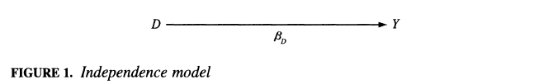
- D = Domestic variable
- Y = Outcome of interest
- Beta D = relationship between D and Y

Direct system effects model
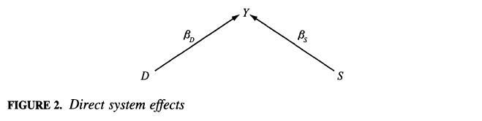
- S = Systemic variable
- Beta S = relationship between S and Y

Indirect system effects model
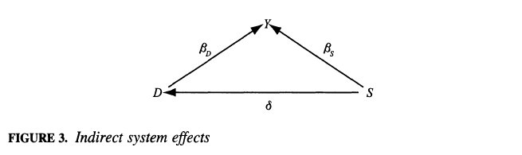
- Delta = relationship between S and D

Moderating effect of systemic variable model
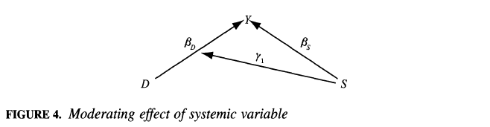
- Gamma 1 = relationship between S and Beta D (aka the relationship between D and Y)

Interdependence model
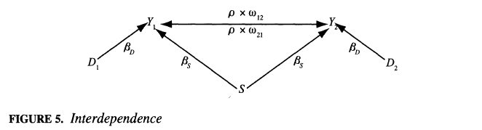
- D2 = 2nd Domestic variable
- Y2 = 2nd Outcome of interest
- Rho * Omega 12 = relationship between Y1 onto Y2
- Rho * Omega 21 = relationship between Y2 onto Y1

Combination model
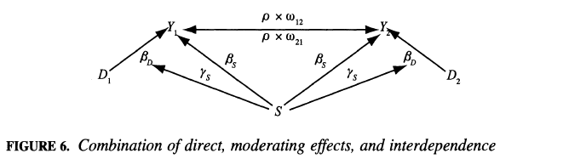
- System variable (S) effects both the Outcome of Interest (Y) and the relationship between the Ds and Ys.

Instructions

Step 1: Select a complex interaction model
- Choose a network model that you are most interested in. In your 1st sentence, clearly declare the network model you selected.

Step 2: Explain why you selected a particular complex interaction model
- In 5 or more sentences, explain why you selected a particular network model.

Rubric
Criteria | Ratings | Points
Model selected | Yes  Missing | 25  0
Selected model explained | 5 sentences  4 sentences  3 sentences  2 sentences  1 sentence  Missing | 75  60  45  30  15  0
Quality: Subjective evaluation by Professor | 01 – Superb  02 – Excellent  03 – Great  04 – Good  05 – Insufficient | 0  0  0  0  0

Chapter 5: Strategic Interaction

About
SIM – Strategic Interaction introduces the concept of strategic interaction (a concept directly related to game theory) to explain instances of “games” between political actors that are non-cooperative, in a single or multiple time periods, and with complete or incomplete information.

While cooperative games allow political actors to establish binding agreements before playing, non-cooperative games do not allow for binding agreements with each other before playing. We will focus on non-cooperative games.

Estimated Time
An estimated 120 minutes is needed to complete this activity.

What is Strategic Interaction?
In a general sense, strategic interaction is about how two political actors interact, given how the other political actors interacts.

Below is a figure that shows 4 different types of strategic interactions based on 2 variables: number of times periods (one or many), and level of information (complete or incomplete).

Four Types of Non-cooperative Games:
- Cell #1 is when there is a one time period and complete information. This is also called a static game of complete information.
- Cell #2 is when there is one time period and incomplete information. This is also called a static game of incomplete information.
- Cell #3 is when there are many time periods and complete information. This is also called a dynamic game of complete information.
- Cell #4 is when there are many time periods and incomplete information. This is also called a dynamic game of incomplete information.

Example 1: Static Game of Complete Information (Cell #1)
Imagine you are walking on the sidewalk from your residence to a nearby park. Now consider that another person is also walking on the same sidewalk, but in the opposite direction (or towards you).

They are walking from the park back to their residence. As you and the other person approach each other, you both have one of two choices to make: either move to the left or move to the right.

The question is: How do you decide which of these two choices to make? The answer is that it depends on what choice the other person makes.
- If the other person moves to the right, which way would you move?
- If the other person moves to the left, which way would you move?

This is one examples of non-cooperative strategic interaction in a single time period with complete information because you are making your choice in a single moment and with completely observing which way the other person moves. And same is true for the other person.

Example 2: Static Game of Incomplete Information (Cell #2)
Imagine there are two political actors: the President of the United States and the Congress. The President must decide whether to threaten vetoing legislation working its way through Congress, knowing that the Congress could ignore his threat, pass legislation, and override his veto. On the other hand, the Congress must decide whether or not to pass the legislation, knowing the president is threatening a veto it.

While both political actors know each other’s actions (i.e. President can veto or sign the legislation, and Congress can override a veto), both political actors may not know which action each other is likely to take. Both actors need to choose at the exact same time which action they will take. Therefore, because it unknown to both actors what their likely action is, this is a static game of incomplete information.

Here are some questions to consider when trying to determine which choices both actors will take:
- If Congress assumes the President will not veto, then what action should Congress take?
- If Congress assumes the President will veto, then what action should Congress take?
- If the President assumes the Congress will not pass legislation, then what action should the President take?
- If the President assumes the Congress will pass legislation, then what action should the President take?

Example 3: Dynamic Game of Complete Information (Cell #3)
Dynamic games are fundamentally different from statics games because there is at least two time periods, or stages, where one political actor must decide what action to take, given the action another political actors has already taken. In other words, unlike the prior examples, where both political actors need to simultaneously need to decide what action to take, dynamic games are were actions are taken sequentially (one actor after another actor).

Consider that there are two political actors: the Federal Government and the Public. The Public needs to decide whether to protest the federal government peacefully or riotously. And the federal government needs to decide whether or not to crack down on the protest, given whether the public is protesting peacefully or riotously.

In a two-time period game, the Public first decides whether to protest peacefully or riotously. In the second time period, the Federal Government decides whether to crack down soft or crack down hard based on the Public’s action.

Here are some questions to consider when trying to determine which choice each actor will make:
- When the Public is deciding to protest calmly or riotously, they should take into account the Federal Government likely response to both protest forms. Why?
- When the Federal Government is deciding to crack down “soft” or “hard”, they decide their action based on the Public’s action. Why?
- Imagine that a 3rd time period introduced to this game. During this 3rd time period, the Public must decide to “retreat” or “fight”. How will the addition of a 3rd stage effect the Public’s choice in stage 1?
- Imagine that a 3rd time period introduced to this game. During this 3rd time period, the Public must decide to “retreat” or “fight”. How will the addition of a 3rd stage effect the Federal Government’s choice in stage 2?

Example 4: Dynamic Game of Incomplete Information (Cell #4)
Dynamic games of incomplete information are different because, again, there are at least two time periods, but both political actors are now lacking some information about the other player’s information or actions.

To fill the gap created by incomplete information, player’s need to form “beliefs” about other players, beliefs which are based on what is observed.

For example, imagine you have two countries that have a history of cooperation, but over more recent years, they are starting to second-guess each other’s motives and willingness to continuing cooperating. These two countries are in a dynamic game since they interact during each period.

However, as time progresses, the two countries are sharing less and less information, thereby moving from a complete information setting, to incomplete information setting. In an incomplete information game, players now need to rely in their “beliefs” of the other player’s actions and payoffs.

While beliefs can range from the implausible to the plausible, both countries should use more plausible beliefs to determine the actions and payoffs of the other players. However, when a country forms their beliefs about the other country, there can be “noise” or “error” that lead to beliefs that are less plausible.

Instructions

Step 1: Select a non-cooperative game type
- Choose one of the four non-cooperative game types listed above that you are most interested in. In your 1st sentence, clearly declare the game type you selected.

Step 2: Explain why you selected a particular game type
- In 5 or more sentences, explain why you selected a particular game type.
- Below are some questions to ask yourself to help you write out 5 or more sentences:
  - How does your game type choice compare or contrast with other game types?
  - What do you think of the example provided for the game type you selected?
  - How does your game type choice relate to your daily life or experiences?
  - How can you apply your game type choice to a strategic interaction you are currently engaged in at home, school, or work?

Rubric
Criteria | Ratings | Points
Game type selected | Yes  No | 25  0
Quantity: # Sentences | 5 sentences  4 sentences  3 sentences  2 sentences  1 sentence  Missing | 75  60  45  30  15  0
Quality: Subjective evaluation by Professor | 01 – Superb  02 – Excellent  03 – Great  04 – Good  05 – Insufficient | 0

Chapter 6: Foreign Crisis

About
SIM – Foreign Crisis is an Assignment where you explain how a foreign crisis requires domestic political actors and international political actors to strategically interact in a complex network.

Estimated Time
An estimated 120 minutes is needed to complete this activity.

What is a Foreign Crisis?
A foreign crisis is something that is happens outside of the country you reside in that attracts the attention of your country’s public, media, or government officials.

Why are Foreign Crises important in International Relations?
Foreign crises are important in international relations for three reasons.

First, foreign crises can affect the interaction between a foreign country’s government and its people. The government of every country, regardless of whether they are democratic or autocratic, are responsible for the safety and well-being of the people within their borders. Thus, when a crisis strikes a country, it is largely because there is some natural event, like an earthquake or typhoon, or human-made event, like civil unrest or military coup, that upsets the status quo and requires actions and reactions between governments and their people.

Second, most countries are keenly interested of what is happening in other countries for the political, economic, social, and military ramifications it can have on them directly, and their allies or adversaries indirectly. This means when natural or man-made disaster strikes a country, it can send waves throughout the international network of countries that disrupts existing political, economic, and social connections. These initial disruptions can cause minor or major slowdowns in countries far beyond the one where the crisis is occurring.

Finally, foreign crises may require the governments of other countries to take actions to buffer from, minimize, or account for the effect of the crisis. Most governments cannot turn on a dime, meaning they are slow to react. Regardless of the speed of the reaction, a reaction must occur which requires government officials, at the very least, and the country’s broader public (people, media, businesses), in the broadest sense, to be discuss, debate, and decide on an action.

Types of Foreign Crises
- Biological weapons attack
- Chemical weapons attack
- Cyberattack
- Major military conflict
- Minor military conflict
- Nuclear weapons attack
- Outer Space anomaly
- Pandemic
- Trade war
- Virus outbreak

Instructions

Step 1: Select a type of Foreign Crisis

Step 2: Provide a real or imagined example of this foreign crisis type

Step 3: Describe how the foreign crisis affects an international political actor

Step 4: Describe how the foreign crisis affects a domestic political actor

Step 5: Describe how the foreign crisis requires a domestic political actor to strategically interact with an international political actor

Step 6: Describe how the foreign crisis restructures a complex network

Rubric
Criteria | Ratings | Points
Declares foreign crisis type | Yes  Missing | 20  0
Provide real or imagined example of foreign crisis | Yes  Missing | 20  0
Describes how crisis affects 1st political actor | Yes  Missing | 20  0
Describes how crisis affects 2nd political actor | Yes  Missing | 20  0
Describes how crisis affects strategic interaction between political actors | Yes  Missing | 20  0
Describes how crisis restructures complex network | Yes  Missing | 20  0
Quality: Subjective evaluation by Professor | 01 – Superb  02 – Excellent  03 – Great  04 – Good  05 – Insufficient | 0

Chapter 7: Share

About
SIM – Share is an opportunity for you to share with your peers any part of the SIM: Domestic Politics, International Politics, Complex Interaction, Strategic Interaction, or Foreign Crisis.

Estimated Time
An estimated 90 minutes is needed to complete this activity.

Instructions

Step 1: Post
- Specify which SIM part you are sharing with the class
- In 3 or more sentences, explain why you wanted to share this part, compared to other, parts
- Ask a specific question that you would like a peer to reply to. Examples of questions include:
  - What do you think of my submission for a specific part?
  - How is my explanation similar to what you wrote for the same part?
  - How is my explanation different from what you wrote for the same part?
  - What is a strength of my submission for the specific part?
  - What is an area I could expand upon for the specific part?

Step 2: Reply to a Peer’s Post
- In 3 or more sentences, respond to the question your peer asked in their original post

Rubric
Criteria | Ratings | Points
Post: SIM part specified | Yes  No | 20  0
Post: Why You Chose to Share this SIM part | 3 sentences  2 sentences  1 sentence  Missing | 30  20  10  0
Post: Included Question for Peer to Respond To | Yes  No | 20  0
Post Quality: Subjective evaluation by Professor | 01 – Superb  02 – Excellent  03 – Great  04 – Good  05 – Insufficient | 0  0  0  0  0
Reply: # sentences | 3 sentences  2 sentences  1 sentence  Missing | 30  20  10  0
Reply Quality: Subjective evaluation by Professor | 01 – Superb  02 – Excellent  03 – Great  04 – Good  05 – Insufficient | 0  0  0  0  0

Chapter 8: My Reflection

About
SIM – Reflection is an opportunity for you share with me, your professor, your thoughts about the Simulation. No other student will read your reflection.

Estimated Time
An estimated 60 minutes is needed to complete this activity.

Instructions
Please write at least 5 sentences reflecting on the Simulation. To be clear, this reflection should focus on the Simulation (domestic politics, international politics, complex interactions, strategic interactions, and foreign crises) as a whole. This reflection should not be about the week's textbook chapter or another assignment.
Sentence #1: Your 1st Sentence should be a question. Examples of questions include:
- How can I apply the simulation to my daily life or academic studies?
- What did you find most interesting about the Simulation? Why did you find this the most interesting?
- What did you find most relevant to your daily life about the Simulation? Why did you find this the most relevant?
- You are welcome to ask and answer your own question.
Sentence #2-5: Sentences 2 through 5 should be your response to the question you posed in sentence #1.

Rubric
Criteria | Ratings | Points
1st Sentence a Question | Yes  No | 25  0
Quantity: # Sentences | 4  3  2  1  0 | 75  60  45  30  0
Quality: Subjective evaluation by Professor | 01 – Superb  02 – Excellent  03 – Great  04 – Good  05 – Insufficient | 0

