GOTV Assignments and Resources

Some resources:

https://www.campusvoteproject.org/resources

https://15fedd24-5236-4bea-bc35-4ea36b399531.filesusr.com/ugd/85cfb4_029803f23c854865800f7a2370177ba2.pdf

https://www.nonprofitvote.org/documents/2016/06/campus-election-engagement-toolkit.pdf/

https://campuselect.org

https://idhe.tufts.edu/sites/default/files/ElectionImperatives.pdf

https://www.tolerance.org/moment/voting-elections

Assignment ideas:

Quick assignment:

- Ask your professor to schedule a Zoom meeting for you to present about “How to Register to Vote in Your State?”
2) Bring three friends to the Zoom meeting. Ask your friends and colleagues to register to vote by using the QR code on the screen!
3) Discuss one of the ballot measures on the Colorado ballot (or your state)

Offer Ballotpedia for Colorado as a point of conversation.

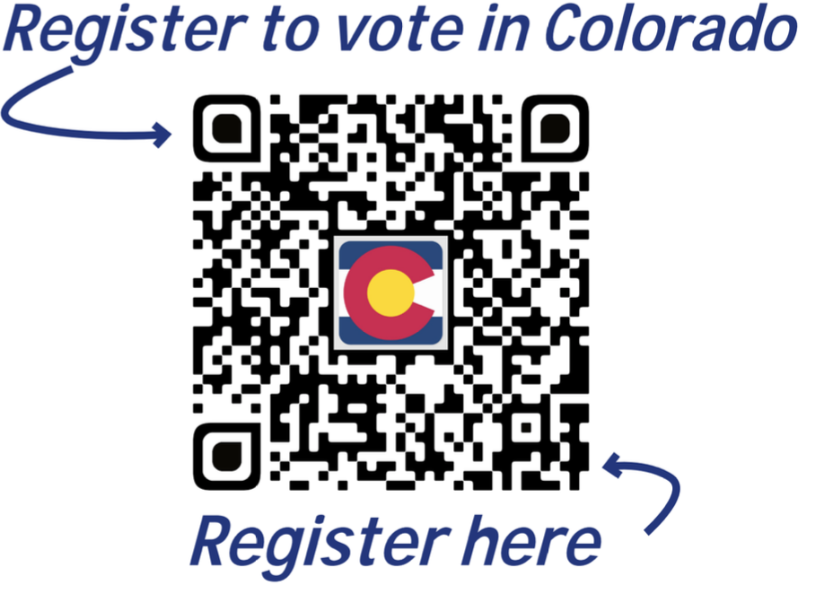

Quick assignment:
- Ask your students to hold a friend and family GOTV party. This can be a virtual party.
- They need to register five people to vote.
- Present one ballot measure to their friends and family.
- As a group make a slogan for the ballot measure (for or against or educational it does not matter—just be creative and think like a voter!)

Quick assignment:
- Ask students to find out how many political parties are running for the presidency on the ballot (pick Colorado or any other state)
- Then have students study each candidate (not Republican and not Democrat) who are on the ballot for the presidency
- With that information have students inform five friends and family members about the candidate’s platform (again not a Republican nor a Democrat).
- Then the student can ask their friends and family to register to vote with the QR codes.

Colorado Ballot Measures (I use this portion for my assignments)
https://ballotpedia.org/Colorado_2020_ballot_measures

Colorado Elections:
https://ballotpedia.org/Colorado_elections,_2020

Colorado and Education (e.g. school districts, University board, etc.)
https://ballotpedia.org/Colorado_state_executive_official_elections,_2020

Possible assignments:
- Students create an educational Public Service Announcement (covering both sides of a ballot issue).
- Students organize panel discussion on campus.
- Students create social media, voting awareness campaigns.
- Students write an OpEd or cover an event related to the election for the college newspaper or for a local newspaper.
Reflection Assignment:

- What Ballot measure or issue did you focus on? Why is this issue important to you and to your community?
- How does the issue fit with the course content?
- What assumptions did you make about the ballot measure before completing this assignment?
- Do you think that your ballot measure or political issue will win or lose in this election?
- Were you surprised by the results of the election with regards to your ballot measure or issue? (after Nov 3)
- What did you learn from participating in this experience?

