Module 2:
Cultivating Democratic Dispositions Flipped Classroom Style

Background

The following classroom exercises have been either created or found publicly available online and adapted to be used in one to two classes for a flipped classroom approach to teaching the general education American Government course at the collegiate level. These are designed to be student-centered learning, where they use the course readings, online resources, etc., to find evidence to produce their own conclusions, as opposed to relying on what their family and/or friends have told them, and/or they have learned from their community. The point is to rely on the collection of one’s own evidence over accepting untested stereotypes. Thus, a key feature for each exercise is that inquiry open with a BIG QUESTION that guides the student’s investigation of politics.

Exercise 4- Foreign Policy Simulation
Big Question
When it comes to foreign policy, does Congress have adequate checks and balances to reign in presidents?

Length of Class Activity
Two class periods, tough to do in one class session

Section of American Government
Foreign Policy; recommended Presidency; Congress

Summary of Lesson
Students roleplay being in the National Security Council (NSC). The have to develop multiple plans—information gathering plan to learn if US is spying and what and who are on the ship, a media plan on if the president should address the public or not and what the message is, a foreign policy negotiation plan (bilateral or multilateral), a military action plan, an economic (embargo?) plan, etc.—for the president on how to handle the crisis. They need to actively use course terms, like bilateralism and/or multilateralism, in their plans.

Student Learning Outcomes
Knowledge-Learn what the National Security Council is, what positions make it up, that it is where foreign policy is developed, and that it only reports to the president
Knowledge-Be able to define multilateralism and bilateralism and discover some tradeoffs of each foreign policy approach
Skill-Critical thinking (NACE Competency)
Skill- Leadership (when assigned individual roles to play) (NACE Competency)
Skill- Communication (NACE Competency)
Skill- Teamwork (NACE Competency)

Resources
Handouts of National Security Council positions, ideally with the current officials in the positions (see https://www.usa.gov/agencies/national-security-council)
Either pull up a random dice roller on a smart phone or bring two 10-sided dice to class for rolling their results.
Optional: Create name placards for key national security council positions for each group

Pre-Activity Work
Read the foreign policy chapter; recommended to have also read the Presidency chapter and Congress chapter of the textbook

Activity
Students are put into groups of 5-6. Inform them they represent the National Security Council (ask them what this body is and does) and that they have been summoned to the “war room” to manage a foreign policy crisis. For each group, give them a copy of the NSC or have them use their smart phone, tablet or laptop to pull us the NSC webpage. As students break into groups, you can have them a) generally play as representing the NSC with no students taking up particular roles or b) have each student in the group choose one of the main offices to play and represent.
- Once students are ready, begin the simulation.
  - Hand out to each group a copy of the group assessment worksheet (see below). Have them all put their names on it. Have the first slide of the Powerpoint displayed (see below). Slide 1 is an informational slide, read it to them.
  - Then, go to slide 2 (Day One), read it, and have them begin brainstorming what they will advise the president to do, as he will be walking through the door in the 15 minutes or so. Also, reveal slide 3 (groups may need you to go back and forth between slides 2 and 3 for round 1). They should first brainstorm what areas (e.g. information gathering plan to learn if US is spying and what and who are on the ship, a media plan on if the president should address the public or not and what the message is, a foreign policy negotiation plan (bilateral or multilateral), a military action plan, an economic (embargo?) plan, etc.) they need to have a plan to present to the president and develop what each of those plans are. These details go in Round 1 on the worksheet. Give them 15-20 minutes to do this. When groups stall or cannot get started, walk around and push them on what they should be doing.
  - If any group decides to take military action in this round, they are officially done with the simulation (but should keep discussing each scenario for the rest of the rounds) and their success or failure will be revealed at the end.
- Once groups have a reasonable set of plans, put Round 1 up on the board and a brief summary of the key elements of each plan for each group. This gets them thinking about if other groups had better plans than them. Present and read slide 4 (Day Five). Give them 10-15 minutes to develop a plan for Day 5. You can now reveal the US was not spying and that this is just an economic cargo with a lot of American crew that Iran has seized.
  - If any group decides to take military action in this round, they are officially done with the simulation (but should keep discussing each scenario for the rest of the rounds) and their success or failure will be revealed at the end.
- Once groups have a reasonable set of plans, put Round 2 up on the board and a brief summary of the key elements of each plan for each group. Give them 10-15 minutes to develop a plan for 1 month.
  - If any group decides to take military action in this round, they are officially done with the simulation (but should keep discussing each scenario for the rest of the rounds) and their success or failure will be revealed at the end.
  - If all groups have taken military action, the simulation ends for the class. Go to slides 7, 8 and 9 to reveal the results.
- Repeat process of step 3 for Round 4. Round 4 is the last round and ends the simulation once groups report their plans. Reveal the results (slides 7, 8 and 9).
  - As needed, have groups roll to see their results using the two 10-sided dice or dice roller on a smart phone. For example, if they took military action on Day 1 or 5, there is so little information known that the odds of success are poor. Thus, the group must roll a 95 or higher or have half or more hostages lost.

Reflection and Debrief
In the assessment worksheet groups submit at the conclusion of the simulation, they are asked to reflect on what they learned from the simulation. The groups need to identify at least one course term or element they better understand and one lesson they learned from the experience of the simulation.

With any time left in class, have a group discussion on the experience, what people saw as the strongest advising plans, what they have learned about foreign policy, etc.

Active Learning Assignment: Foreign Policy Simulation
Foreign Policy Simulation
NSC Informational Handout: Give this to the groups at the start of the simulation.
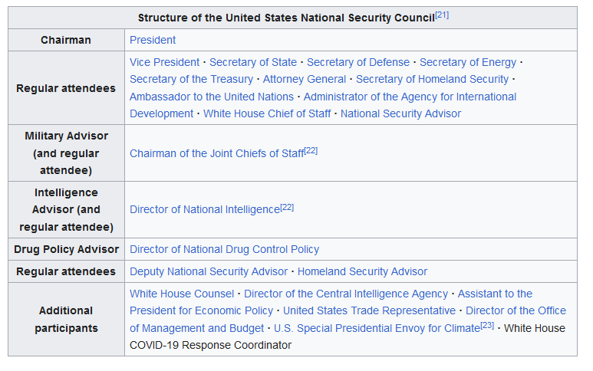

Advising the President on Foreign Policy
- What key departments and agencies are represented in the NSC and what should they be doing to prepare for and inform the president about the crisis situation?
______________________________________________________________________
______________________________________________________________________
______________________________________________________________________
______________________________________________________________________
- What areas do you need to be prepared to debrief the president on and be formulating plans and making recommendations for how to proceed?
_________________________________ __________________________________
__________________________________ __________________________________
__________________________________ __________________________________

- What do you advise the president to do? These are not mutually exclusive, you can do more than one.
-Do nothing but demand their return
-Attempt diplomacy
-Appeal to the United Nations
-Use financial incentives
-Threaten to use force and direct the military to plan a rescue mission
-Take military action (What action?)
-Address the public
You may want to pursue more than one of these simultaneously. You may also consider actions beyond those listed above. You may want to map out a timetable of actions for the crisis based on a a) a week-long, b) a month-long and c) a year-long crisis.
As you discuss and develop your plan, be sure to consider and use the following course concepts:
Global power distribution and US superpower or hegemonic status
Bilateral versus multilateral relations
Interventionist versus neutral versus isolationist foreign policy

Round 1 ______________________________________________________________________
_____________________________________________________________________________
_____________________________________________________________________________
_____________________________________________________________________________
Round 2 ______________________________________________________________________
_____________________________________________________________________________
_____________________________________________________________________________
_____________________________________________________________________________
Round 3 ______________________________________________________________________
_____________________________________________________________________________
_____________________________________________________________________________
_____________________________________________________________________________
Round 4 ____________________________________________________________________
_____________________________________________________________________________
_____________________________________________________________________________
Group Reflection
1) What have you learned about foreign policy from the simulation?
______________________________________________________________________
______________________________________________________________________
______________________________________________________________________
______________________________________________________________________
2) What are at least two course materials the simulation has helped you better understand? How?
______________________________________________________________________
______________________________________________________________________
______________________________________________________________________
______________________________________________________________________
3) Any additional comments you have after reflecting on your experiences from the simulation?
______________________________________________________________________
______________________________________________________________________
______________________________________________________________________
______________________________________________________________________

