Module 2:
Cultivating Democratic Dispositions Flipped Classroom Style

Background

The following classroom exercises have been either created or found publicly available online and adapted to be used in one to two classes for a flipped classroom approach to teaching the general education American Government course at the collegiate level. These are designed to be student-centered learning, where they use the course readings, online resources, etc., to find evidence to produce their own conclusions, as opposed to relying on what their family and/or friends have told them, and/or they have learned from their community. The point is to rely on the collection of one’s own evidence over accepting untested stereotypes. Thus, a key feature for each exercise is that inquiry open with a BIG QUESTION that guides the student’s investigation of politics.
Exercise 2- Investigating Federalism
Big Question
What government most shapes and influences your political life?
[Stereotypically Americans only think of the federal government, although most interact and are impacted much more by state and local government.]

Length of Class Activity
One class

Section of American Government
Federalism Chapter, State and Local Government Chapter

Summary of Lesson
One of the most challenging elements of American politics is knowing which level of government can address the issue an American has or wants changed. This lesson is designed to challenge students to learn what powers and responsibilities the federal and state governments have, where those overlap and where they are exclusive to one or the other.

Student Learning Outcomes
Knowledge-Understand the three types of powers (enumerated, concurrent, and reserved powers).
Knowledge-Know at least 3 or more powers and responsibilities for each the federal government and the state governments, as well as 3 or more powers and responsibilities they share.
Skill- Critical thinking (NACE Competency)
Skill- Communication (NACE Competency)
Skill- Teamwork (NACE Competency)

Resources
US Constitution
NOTE: NO smart phones, tablets or laptops

Pre-Activity Work
Read the federalism chapter and/or state and local government chapter

Activity
In a flipped classroom, the instructor needs to walk around, look for inactive students and groups, help them and answer their questions, and keep them on task. The challenge is to give them guidance but avoid just giving them answers.
- At the start of class, each student is given 2 sheets (see below). The first has a list of 21 powers and responsibilities and the second is a Venn diagram representing (see below). The students are to properly label on segment (right or left area) with the federal power (enumerated or explicit powers), the opposite area (right or left) as state power (reserved), and the middle area as their shared powers (concurrent). Then, they are to use the powers and responsibilities sheet and place the 21 powers on it in the 3 areas of the Venn diagram. Done correctly, there are 7 different powers and responsibilities in each area using all 21. Explain the exercise is not meant to trick them, that if 90% of the responsibility is one level of government, the power goes there (e.g., there are US Marshalls that are a “federal” police, but police goes in state powers). Students are to first complete it individually. Give them 15-20 minutes or more as needed. To motivate students, you can offer that if anyone completes it correctly, s/he is free to leave class early. [Note: No one ever completes it individually correctly, typically because they cannot do the labels across the top or have one or two powers in the wrong place.]
- After everyone has reasonably complete the worksheet to the best of their ability, then have them pair up to compare their answers. Give them approximately another 10 minutes. Again, if any pair that completes it correctly, they can leave class early.
- After pairs have completed their work, put them in groups of 4 or 5 and have them use the remainder of the class to complete a group sheet (have extras of the Venn diagram to give them a clean worksheet) to submit for assessment. Again, if any group completes it correctly, they can leave class early.

Reflection and Debrief
With the last few minutes of the class, require all groups put their names on the group sheet and turn them in. If any students or pairs completed it correctly early and left, be sure to keep their worksheets (or names) to enter their grade in your gradebook. Take a few minutes to ask them again, after completing this worksheet, what form of government most affects your daily life. Also, ask them to reflect on this worksheet. What have they learned? What surprised them about the activity? Cover the most commonly missed answers (post office, welfare/health care as it is now a more concurrent power with Obamacare, etc.). Note that powers can move from one category to the other.

Federalism Worksheet Key
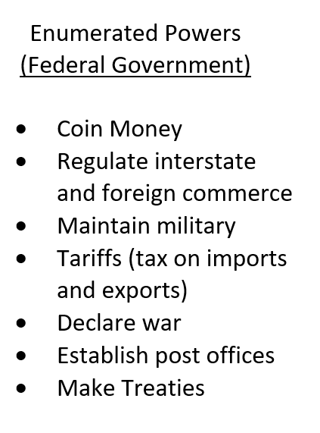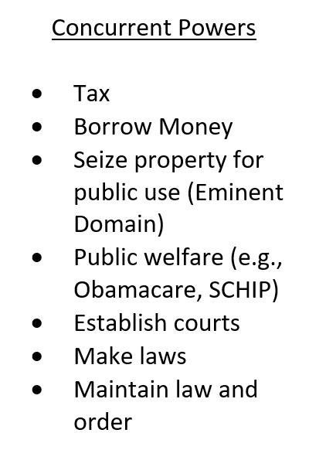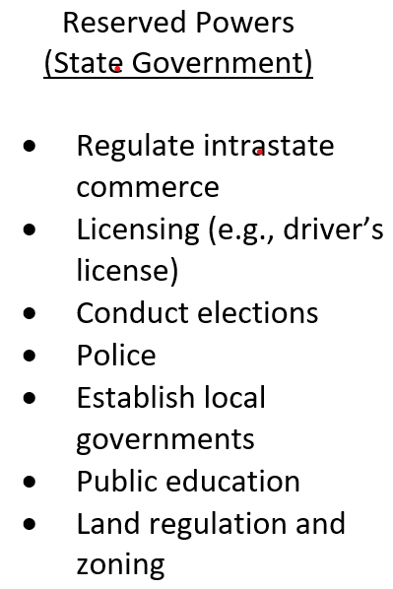
Active Learning Assignment: Federalism Sorting the Powers of Government Class Activity
Directions: Label the 3 sections of the Vinn diagram for the type of power of federalism in the US, then place the appropriate power in each section (7 powers per section).
Federalism Worksheet
Powers Powers Powers
Tax Conduct elections Coin Money

Regulate interstate Seize property for public Regulate intrastate
and foreign commerce use (Eminent Domain) commerce

Declare war Make treaties Public education

Licensing Police Maintain military
(e.g., drivers license)

Borrow money Public welfare (e.g., Establish courts
Obamacare, SCHIP)

Establish post offices Establish local governments Maintain law and
order

Tariffs (tax on imports Make laws Land regulation
and exports) and zoning

