Lesson: Comparing Formal and Informal Institutions using Real-World Examples

Megan Hauser
Senior Lecturer of Political Science
Kennesaw State University
Kennesaw, GA

Modality
This assignment can be used in an in-person course, a hybrid course, or a fully online course

Intended Learning Outcomes:
Explain the difference between Formal and Informal Institutions.
Analyze the Levitsky and Helmke (2006) typology on the relationship between Formal and Informal Institutions
Apply the concepts to a real-world example (in this case, an article on a caste census in India in 2023)
Draw a conclusion about how the real-world example shows the significance of informal institutions on specific formal institutions (in this case, how a nationwide census on caste membership in India might affect electoral politics, reserved seats and political party dynamics)

Prior to class, students were assigned to read:
Chapter 3: Institutional Perspectives in Politics in the Developing World, 2017, edited by Peter Burnell. Oxford University Press

In class or in a pre-recorded video uploaded to course learning management system:

Go through selected slides

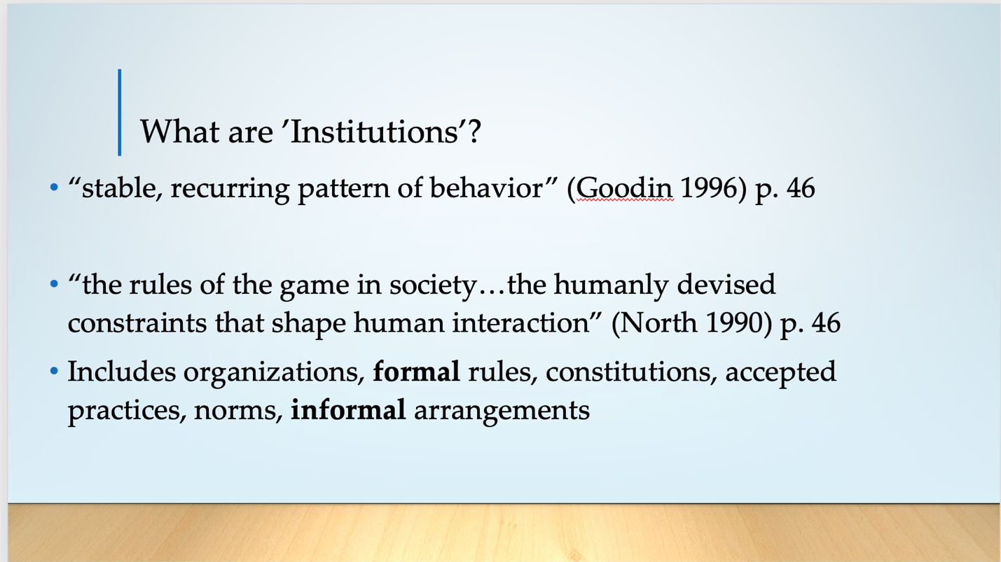

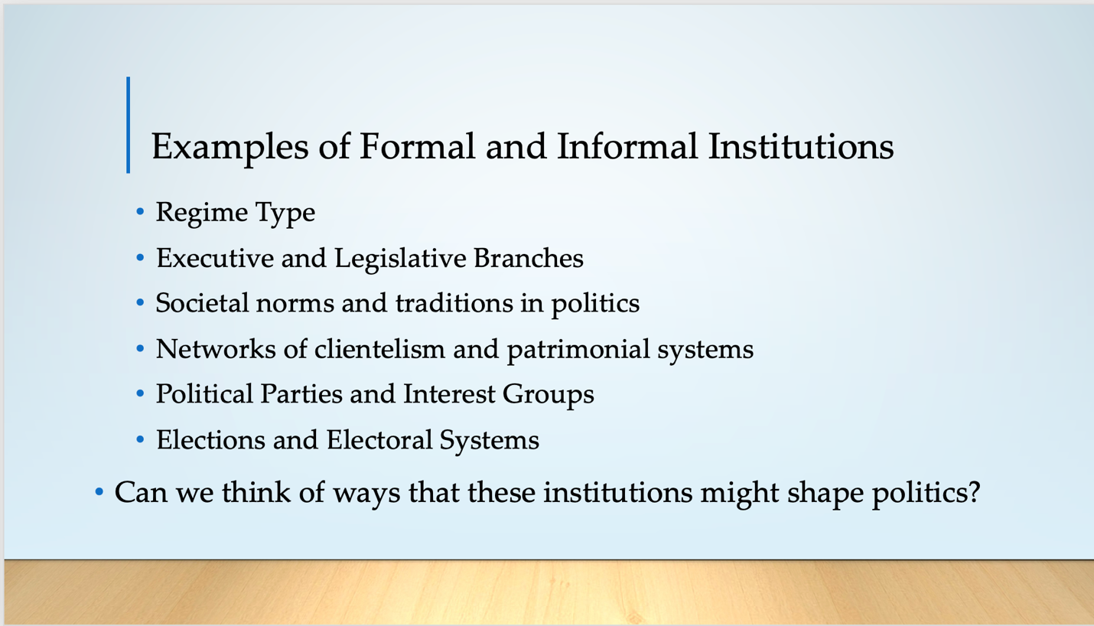

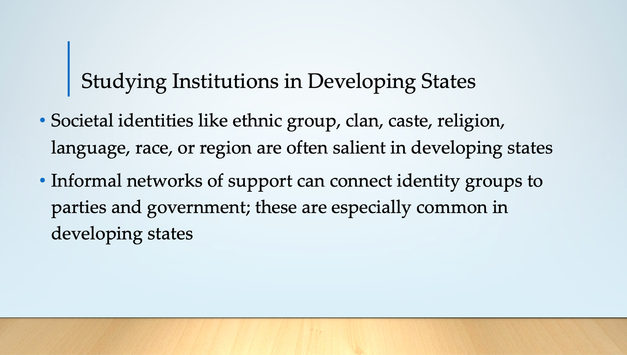

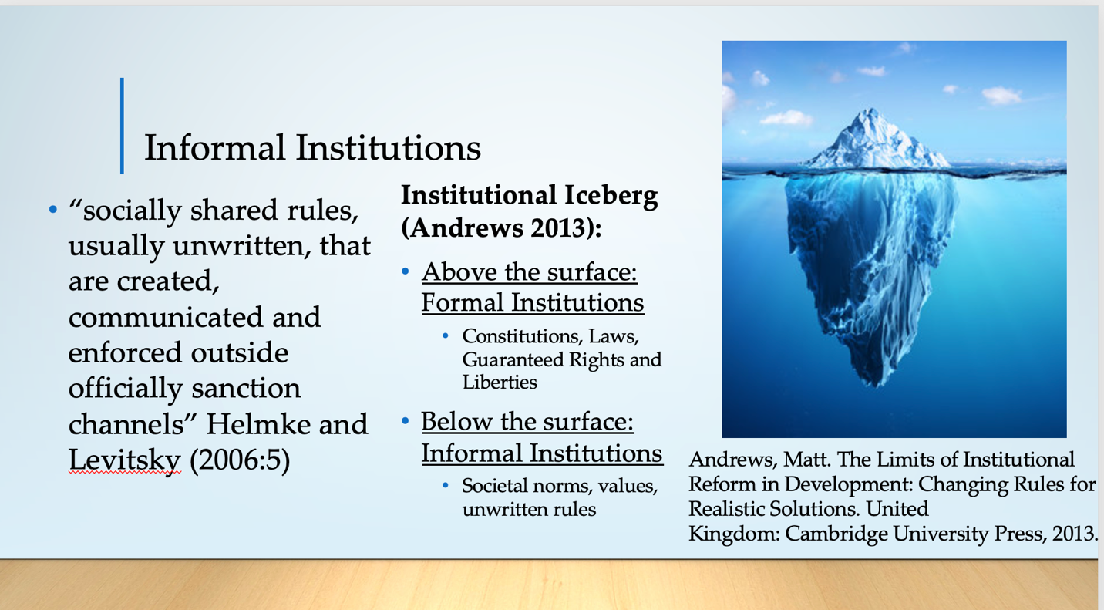

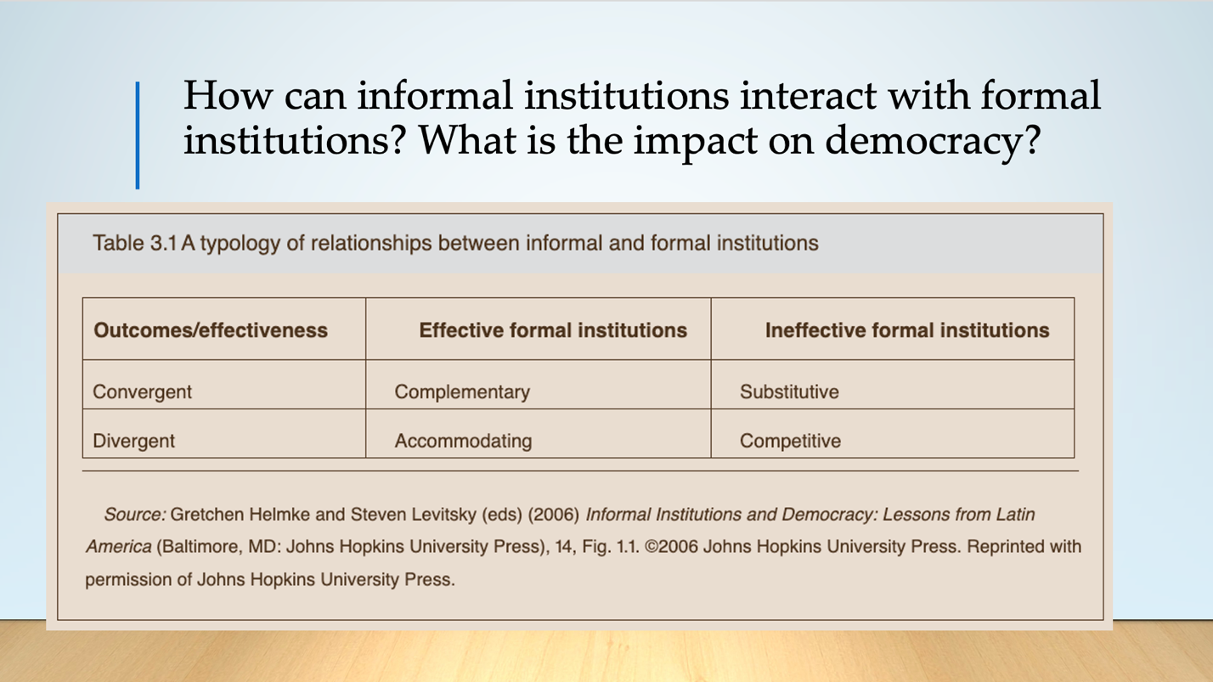

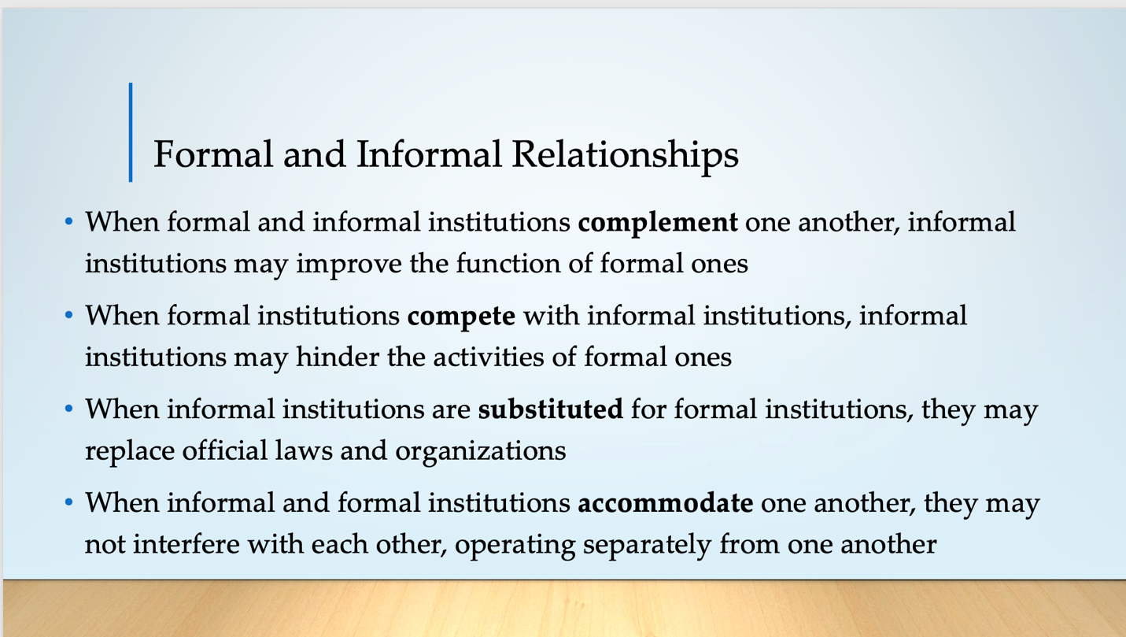

In class, or online in Discussion in the course learning management system:

Select a news article that brings up real-world examples of informal institutions, especially in the Global South

Example:
Washington Post article “For India, a caste survey could lead to political upheaval” by Karishma Mehrotra. May 8, 2023.

Complete Discussion Assignment

In class or Online Discussion Prompt:
As we have read in Chapter 3, there are different perspectives on the role that institutions play in developing states. One of the biggest questions is to what extent are formal versus informal institutions considered? This is especially relevant in India, which has established democratic institutions but also a long history of informal institutions, one example of which is the caste system. Read the provided article from the Washington Post that discusses a new survey on caste membership in India. In this case, do you think that the example of the caste census in India shows a complementary, substitutive, accommodating and/ or competitive relationship between formal and informal institutions? Why do you think so? Considering the points made on pages 51-55, what might be the risks and benefits to redesigning India's political institutions because of this survey? Do you think they should? Explain why you think so.
Listen to, or read, your classmates’ points and answers to these questions.
In general, what do you see as some of the major challenges and limitations to studying informal institutions in Comparative Politics, especially from a Western setting? What do you think can be done to address these challenges and to overcome them in research, in teaching, and in policy practice? Brainstorm with your classmates.

Further Reading:
Andrews, Matt. 2013. The Limits of Institutional Reform in Development: Changing Rules for Realistic Solutions. Cambridge:: Cambridge University Press.
Goodin, Robert. 1996. The Theory of Institutional Design. Cambridge: Cambridge University Press.
Helmke, Gretcher and Steven Levitsky. 2006. Informal Institutions and Democracy: Lessons from Latin America. Baltimore, MD: Johns Hopkins University Press.
North, Douglass. 1990. Institutions, Institutional Change and Economic Performance. Cambridge: Cambridge University Press.

